Most Important Books for JEE Main and JEE Advanced

[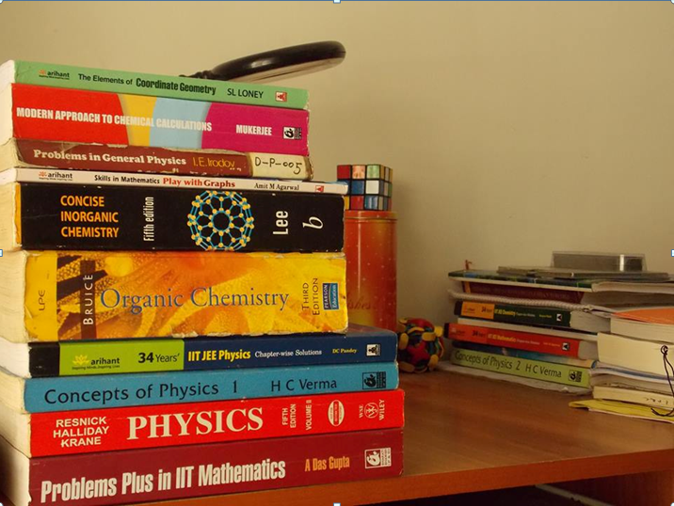](http://www.meritnation.com/testprep/hub/wp-content/uploads/2015/08/iit-jee.png)One of the most significant requirements for effective JEE preparation is finding the best textbooks and notes, right? With the extensive JEE syllabus and the limited time available for preparation, choosing the right books for the right subjects becomes crucial. Add to that the vast sources of information available over the internet, it comes extremely confusing to figure out what all and how many books to study from.

Some of our experienced faculty, who are also IIT alumni, have listed here the most important reference books for JEE, which are essential for an effective JEE preparation.

|  |  |  |  |  |
| --- | --- | --- | --- | --- |
| **MATHS** | **PHYSICS** | **CHEMISTRY** | | |
| **Physical Chemistry** | **Organic Chemistry** | **Inorganic Chemistry** |
| Objective Mathematics (RD Sharma) | Concept of Mathematics (Part 1 and 2) (HC Verma) | Physical Chemistry for Competitions (OP Tandon) | Organic Chemistry for Competitions (OP Tandon) | A Textbook of Inorganic Chemistry (RK Gupta) |
| IIT Mathematics (For Algebra) (ML Khanna) | Problems in General Physics (IE Irodov) | Modern Approach to Chemical Calculations (RC Mukherjee) | Organic Chemistry (Morrison and Boyd) | Concise Inorganic Chemistry (JD Lee) |
| Higher Algebras (Hall and Night) | Fundamental Physics (Halliday, Resnick and Walker) | Physical Chemistry – P. Bahadur | Organic Chemistry – Himanshu Pandey (GRB Publication) |  |
| Plane Trigonometry (SL Loney) | Aptitude Test Problems in Physics (SS Krotov) | Physical Chemistry – K.S. Verma (Cengage Publication) | Organic Chemistry – M. S. Chauhan (Balaji Publication) |  |
|  | New Pattern Physics (DC Pandey) Arihant Publications |  |  |  |

## MATHS:

When it comes to preparing Math for an entrance exam, all you can think of continual practice. Unlike Physics and Chemistry, which have parts of theory and practical questions, Maths is mostly concentrated on practising and attempting questions after learning the concepts. JEE Math too has got a lot to do with knowing the concepts to perfection and being able to apply the same into a varied style of questions.

Here are some important JEE Text Books that have both the explanation of concepts and solved/unsolved questions for practice.

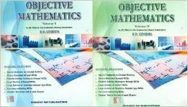**1. Objective Mathematics (RD Sharma)**  
Coming from the most popular and the most widely prescribed author for Math students in school, Objective Mathematics by RD Sharma is ideal for JEE Math preparation too. Those appearing for state level entrance examinations, apart from the JEE, will also find this book helpful. The book will cater to your needs of comprehensive explanation of topics, that too, without tiring you out. To the point and simplistic, the notes will strengthen your foundation too. If there was only one book you wanted to study JEE Math from, RD Sharma’s Objective Mathematics would be the ideal choice. Solved examples and series of practice questions make it ideal for quick revision too.

**2. IIT Mathematics (For Algebra) (ML Khanna)**[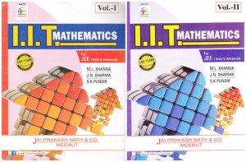](http://www.meritnation.com/testprep/hub/wp-content/uploads/2015/08/IIT-Maths-ML-Sharma.jpg)  
For Algebra as well as for Vectors, ML Khanna has the right amount of practice questions and explanation of theory. A lot of students also feel that studying from just this one book will also help you prepare effectively for JEE. The book contains varied styles of questions to prepare you in an all-round manner.

[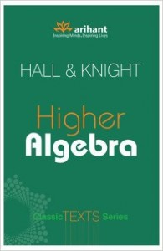](http://www.meritnation.com/testprep/hub/wp-content/uploads/2015/08/3.-Higher-Algebra-Hall-and-Night.jpg)**3. Higher Algebras (Hall and Night)**  
This particular book is the best bet when you want to practise Algebra. For JEE preparation, students can make use of the many tricky and complex questions in the book, and clear their concepts using the best analytical methods. Topics like sequencing, permutations, combinations, etc., can be mastered with the help of Higher Algebra by Hall and Knight. The subjective pattern of the book makes it slightly unsuitable for JEE preparation sometimes, but the book introduces students to new concepts and theorems in a very interesting manner.

**4. Plane Trigonometry (SL Loney)**[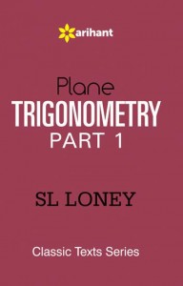](http://www.meritnation.com/testprep/hub/wp-content/uploads/2015/08/4.-Plane-Trigonometry-SL-Loney.jpg)  
The book is probably the best bet for practising Trigonometry. Considered one of the easier topics in the subject in general, this book will help you gain additional knowledge in the subject. The questions included are divided into the basic and advanced levels, making it easier for one to get the concepts more thoroughly. The book has not been written with competitive exams in mind, yet there is a lot of scope to learn from the chapter explanations.

## PHYSICS:

[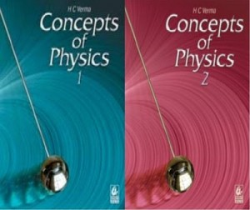](http://www.meritnation.com/testprep/hub/wp-content/uploads/2015/08/1.-Concept-of-Physics-Part-1-and-2-HC-Verma.jpeg)**1. Concept of Physics (Part 1 and 2) (HC Verma)**  
HC Verma’s books, recommended as supplementary reading material for students of class 11 and 12, become the most easily available options for students. HC Verma Physics books have notes that are comprehensive and ample practice questions, with solutions. In fact, this can become the sole Physics book you can prepare for JEE with. Moreover, for students who wish to find detailed answers to the questions in these books, there are several online sources where you could find HC Verma Solutions for free.

**2. Problems in General Physics (IE Irodov)**[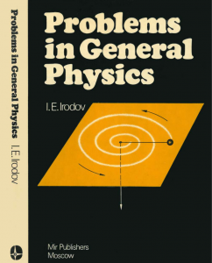](http://www.meritnation.com/testprep/hub/wp-content/uploads/2015/08/2.-Problems-in-General-Physics-IE-Irodov.png)  
The study material and practice questions in Irodov’s Physics are slightly more complex than those in HC Verma’s. Many would not recommend JEE aspirants to study from the book due to the high difficulty level of the questions and topics. However, if you feel you could take on the advanced difficulty level, Irodov will be the book for you.

[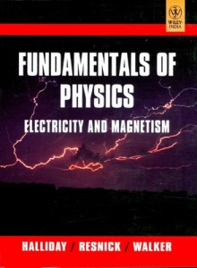](http://www.meritnation.com/testprep/hub/wp-content/uploads/2015/08/3.-Fundamental-Physics-Halliday-Resnick-and-Walker.jpeg)**3. Fundamentals of Physics (Halliday, Resnick and Walker)**  
Fundamental Physics by Halliday, Resnick & Walker comes next in line after HC Verma’s Concept of Physics, when it comes to understanding concepts. The book explains various topics using real-life examples. The book, however, helps you in strengthening your theory; you can give it a miss if you’re looking for only practical questions.

**4. Aptitude Test Problems in Physics (SS Krotov)**[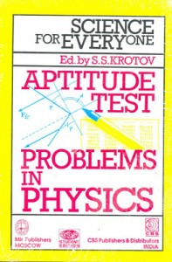](http://www.meritnation.com/testprep/hub/wp-content/uploads/2015/08/4.-Aptitude-Test-Problems-in-Physics-SS-Krotov.jpeg)  
This book is preferred for mostly the many MCQ style questions in it. Students looking for additional practice for the Physics portion in JEE can utilise their time with this book. If you are looking for a book that can help you practice questions for JEE, i.e., the multiple choice question format, you could use Krotov.

[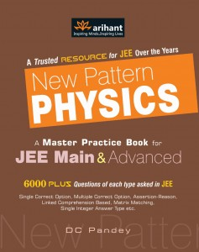](http://www.meritnation.com/testprep/hub/wp-content/uploads/2015/08/5.-New-Pattern-Physics-DC-Pandey-Arihant-Publications.jpeg)**5. New Pattern Physics (DC Pandey) Arihant Publications**  
If you are planning to use the tried and tested books for JEE Physics, DC Pandey definitely falls in the list. The book contains the regular format of explained concepts and followed by questions and answers. It additionally contains past years’ solved answers to help students prepare more comprehensively from a single book.

## CHEMISTRY:

## Physical Chemistry

**1. Physical Chemistry for Competitions (OP Tandon)**[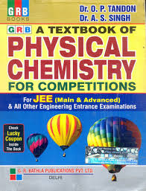](http://www.meritnation.com/testprep/hub/wp-content/uploads/2015/08/1.-Physical-Chemistry-for-Competitions-OP-Tandon.jpg)  
One of the most popular books for Physical Chemistry, OP Tandon’s book is used incessantly for all engineering entrance exams. The book covers all topics in detail. You’ll gain both in case of theoretical and practical type questions. The practice papers and solved questions are a huge benefit in this book. The best thing is, you also get OP Tandon books for Organic and Inorganic Chemistry.

[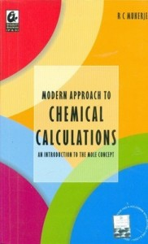](http://www.meritnation.com/testprep/hub/wp-content/uploads/2015/08/2.-Modern-Approach-to-Chemical-Calculations-RC-Mukherjee.jpeg)**2. Modern Approach to Chemical Calculations (RC Mukherjee**)  
This one’s by far the best bet for Physical Chemistry. Well-explained topics and concepts, and varied styles of numerical questions in this book make it a one-stop solutions for JEE preparation of Physical Chemistry. The entire JEE syllabus for Physical Chemistry can be easily covered with this book. Other beneficial features include revision notes and solved questions in the end. The mole concept has been described well and questions are explained using the same.

**3. Physical Chemistry – P. Bahadur**[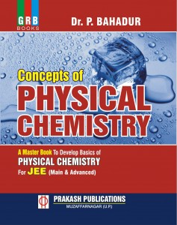](http://www.meritnation.com/testprep/hub/wp-content/uploads/2015/08/3.-Physical-Chemistry-%E2%80%93-P.-Bahadur.jpg)  
It’s one of the most highly recommended books for physical chemistry and for numerical problems for any engineering entrance exam. The set of problems in the book are very exhaustive. The problems available are from state level engineering entrance exams to JEE for each chapter in the book.

[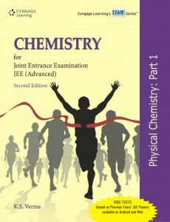](http://www.meritnation.com/testprep/hub/wp-content/uploads/2015/08/4.-Physical-Chemistry-%E2%80%93-K.S.-Verma-Cengage-Publication.jpg)**4. Physical Chemistry – K.S. Verma (Cengage Publication)**  
Physical Chemistry for JEE is a comprehensive guide for students who are studying for the Physical Chemistry for JEE. While its illustrative and solved examples will facilitate easy mastering of the concepts and their applications, an array of solved problems will expose the students to the variety and nature of questions that they can expect to face in the examination. The coverage and features of this series of books make it highly useful for all those preparing for JEE Advanced and aspiring to become engineers.

## Inorganic Chemistry

**1. A Textbook of Inorganic Chemistry (RK Gupta)**[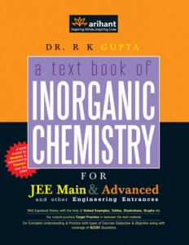](http://www.meritnation.com/testprep/hub/wp-content/uploads/2015/08/1.-A-Textbook-of-Inorganic-Chemistry-RK-Gupta.jpg)  
The theory is very well-explained for all the topics and chapters. There is good scope for revision and quick recaps with every chapter. Practise questions are available at the end of every chapter as well as the end of the book too, hence strengthens students’ preparation. The type of questions included are comprehension, reasoning and assertion type of questions, MCQ’s, short answers-questions and analytical questions.

[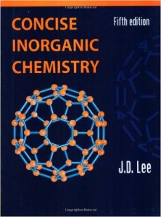](http://www.meritnation.com/testprep/hub/wp-content/uploads/2015/08/2.-Concise-Inorganic-Chemistry-JD-Lee.jpg)**2. Concise Inorganic Chemistry (JD Lee)**  
JD Lee’s Chemistry book is among the most popular for Inorganic Chemistry, not just for JEE, but for other engineering entrances as well. The essentials are well-covered, and the practice questions are in abundance. The format of questions in the book includes MCQs, assertive -type and single choice questions. The practical and theory parts in the book are well-balanced too.

## Organic Chemistry

**1. Organic Chemistry for Competitions (OP Tandon)**[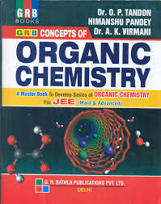](http://www.meritnation.com/testprep/hub/wp-content/uploads/2015/08/1.-Organic-Chemistry-for-Competitions-OP-Tandon.jpg)  
The book gives you a lot of scope to learn and revise. The text is well-formatted and revised to match the current trends of of the examination. The text is precise and short; hence, easy to understand. You can know and practise the most recent questions for Organic Chemistry for JEE. The type of questions included in the practice part include Multiple Choice Questions, reasoning and matching options.

[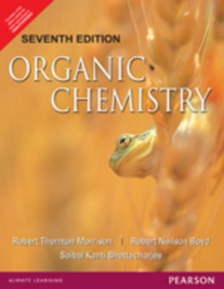](http://www.meritnation.com/testprep/hub/wp-content/uploads/2015/08/2.-Organic-Chemistry-Morrison-and-Boyd.jpeg)**2. Organic Chemistry (Morrison and Boyd)**  
The book covers almost all the topics in the JEE syllabus in good detail. You can strengthen your knowledge on Molecular Structure and other important topics from Organic Chemistry. Students prefer preparing Organic Chemistry for JEE with Morrison and Boyd owing to the interesting way in which even the most complex topics are made understandable. There are no substantial questions for practice purposes in the book, but it is ideal for understanding the concepts of Organic Chemistry for JEE.

**3. Organic Chemistry – Himanshu Pandey (GRB Publication)**[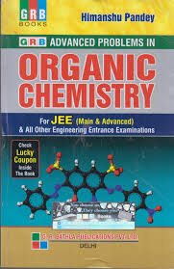](http://www.meritnation.com/testprep/hub/wp-content/uploads/2015/08/3.-Organic-Chemistry-%E2%80%93-Himanshu-Pandey-GRB-Publication.jpg)  
This is a comprehensive guide for Organic Chemistry and is essential for both the JEE Main and Advanced exams. Every chapter contains the entire spectrum of objective questions as adopted by IIT JEE. Teachers and students will find all type of problems that covers the core curriculum of typical organic chemistry. Maximum problems in this book are designed by combining two or more concepts. Answering them need thinking and deep knowledge.

[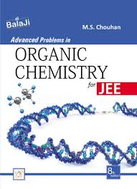](http://www.meritnation.com/testprep/hub/wp-content/uploads/2015/08/4.-Organic-Chemistry-%E2%80%93-M.-S.-Chauhan-Balaji-Publication.jpg)**4. Organic Chemistry – M. S. Chauhan (Balaji Publication)**  
The book aims at three problematic key areas of the organic chemistry – understanding of mechanics, visualization of structures and problem solving. The reactions are well illustrated and elaborate answers with stepwise explanations of their mechanisms are provided. These are combined with concise text helping students to acquire the fundamental concepts of the subject.

Apart from these,[NCERT Books](http://www.meritnation.com/ncert-books) for Class XI and XII for all three subjects, i.e., Physics, Chemistry and Math would definitely help students preparing you for the JEE exam, as the question patterns of the books and the exam are similar.